Table of Contents

Introduction to Covid-19 2

Data Collection and Methodology 3

Data analysis and interpretation: 3

COVID-19 Impact on Financial Markets Returns 5

Covid-19 impact on Financial Markets Cumulative Returns 6

Interpretation: 6

Impact on Crude oil 6

Impact on SP500 6

Impact on Gold: 7

Impact on TLT: 7

Relationship between returns of S&P500 and returns of Crude oil 7

Scatter Plot of S&P500 versus Crude oil 7

Relationship between returns of S&P500 and returns of Gold 8

Scatter Plot of S&P500 versus Gold 8

Relationship between returns of S&P500 and returns of TLT 8

Scatter Plot of S&P500 versus TLT 8

Correlation Matrix 9

Drawdown 9

Drawdown of S&P500 due to Covid-19 9

Drawdown of Crude Oil due to Covid-19 10

Drawdown of Gold due to Covid-19 10

Drawdown of TLT due to Covid-19 11

Summary of Drawdown due to Covid-19 11

IMPACT OF COVID-19 on various sectors. 12

Sectoral performance during Covid-19 outbreak 12

Country-by-country Covid-19 trajectory on Apr 05, 2020 13

When Covid-19 will end? 13

SARS Drawdown 14

Table of SARS Drawdown 14

Impact of SARS on cumulative returns during and after the outbreak 15

Importance of Social Distancing 16

Conclusion 16

References 17

Impact of COVID-19 on financial markets: Quantitative analysis

# Introduction to Covid-19

The human cost of the coronavirus (Covid-19) outbreak has continued to mount, with more than 1.2m cases confirmed globally and more than 64,600 people known to have died from the virus.  The World Health Organization has declared the outbreak a pandemic and it has spread to more than 190 countries around the world.

Europe became the focal point of the disease in early March when it spread rapidly across the continent and Italy became the country hardest hit by Covid-19 after China. After weeks of strict lockdown, Italy is on the verge of turning the corner and the rate of deaths is beginning to decrease. The US is still in the acceleration phase.

In this research topic, we will try to analyze impact of Covid-19 on various financial markets including ***Gold, Crude oil, TLT (Treasury Bond) and ^GSPC (S&P500)*** as well as we will analyze impact of various past pandemics on these financial markets.

# Data Collection and Methodology

Click on [Link](../GSPC.xlsx) for S&P500 dataset

Click on [Link](CL=F.csv) for Crude Oil dataset

Click on [Link](GC=F.csv) for Gold dataset

Click on [Link](TLT.csv) for TLT dataset

We have collected data from Yahoo Finance for **Gold, Crude Oil, TLT and S&P500** from **Nov 17, 2019** because it is the date on which first case of Covid 19 was found. We will try to understand pattern in Returns as well as Cumulative Return from **Jan 30,2020** when World Health Organization (WHO) declares "**Public Health Emergency**" due to Covid-19.

# Data analysis and interpretation:

We calculated percentage change in **Close Price** and plotted the daily returns of S&P500 of US.

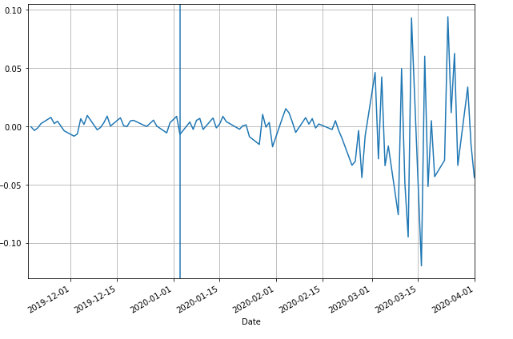

**Interpretation:**

We can see **volatility** in daily returns in S&P500 after Covid-19 was declared **Public Health Emergency.**

# COVID-19 Impact on Financial Markets Returns

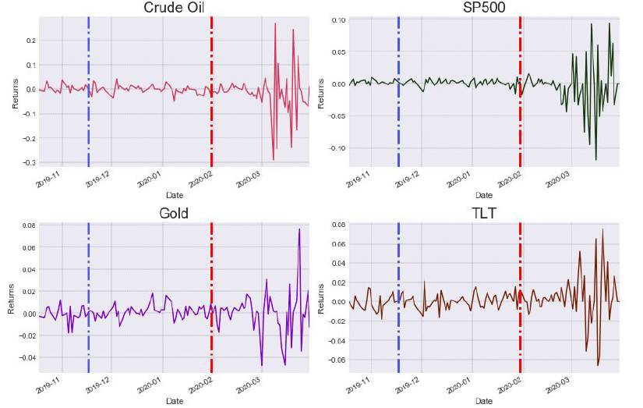

**Interpretation of graph:**

Blue vertical dotted line is **Nov 17, 2019 when First case of Covid-19 found.**

Red vertical dotted line is **Jan 30, 2020 when WHO declared "Public Health Emergency"**

We can see lot of volatility in all instruments after WHO declared "**Public Health Emergency"**

# Covid-19 impact on Financial Markets Cumulative Returns

Following graph shows **Cumulative Returns** of financial instruments i.e. Crude Oil, SP500, Gold and TLT(treasury bond).

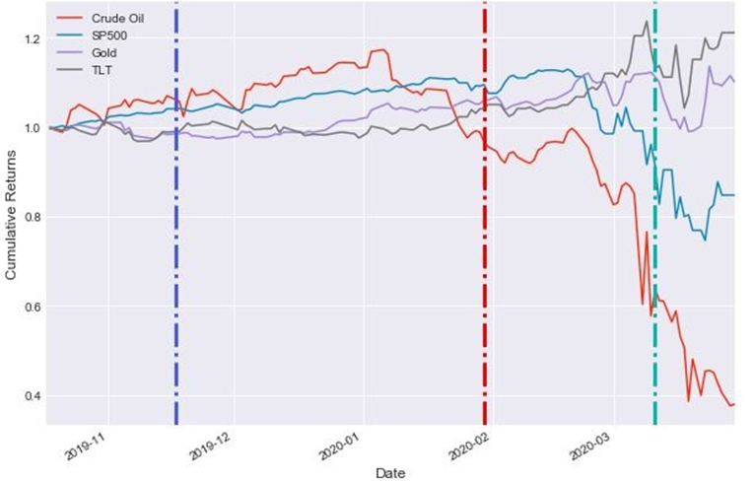

Whenwe plotted cumulative returns from **Nov 17, 2019 (First case of Covid19)**, we can interpret that when WHO declared Covid-19 as Pandemic and Emergency on **Mar 11, 2020,** there is lot of volatility in Crude Oil, S&P500, GOLD and TLT.

## Interpretation:

Impact on Crude oil: After WHO declared Covid-19 Public Health Emergency on Jan 30, 2020, there is tremendous negative impact on crude oil. There is continuous decline in crude oil and it is the most impacted financial instrument among four.

Impact on SP500: Second most impacted instrument is S&P500 after WHO declared Covid-19 Public Health Emergency on Jan 30, 2020. As we can see there is negative relationship between any pandemic and S&P500.

Impact on Gold: There is continuous increasing trend in Gold even after first case of Covid-19 was found in Nov 17, 2019. There is Positive correlation between Covid-19 and Gold which also makes sense because Gold is considered as safe haven for many investors.

Impact on TLT: Since treasury bonds are considered as Risk-Free bonds, we can see continuous upward trend in TLT. In fact, TLT is best alternative among four which yields high cumulative returns.

# Relationship between returns of S&P500 and returns of Crude oil

## Scatter Plot of S&P500 versus Crude oil

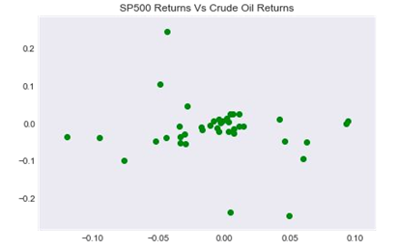

**Interpretation:**

Difficult to find any correlation between S&P500 and returns of Crude Oil

# Relationship between returns of S&P500 and returns of Gold

## Scatter Plot of S&P500 versus Gold

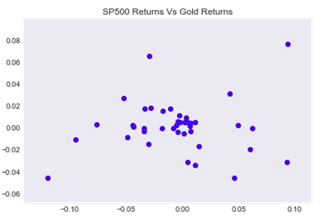

**Interpretation:**

Very weak correlation between S&P500 and Gold returns

# Relationship between returns of S&P500 and returns of TLT

## Scatter Plot of S&P500 versus TLT

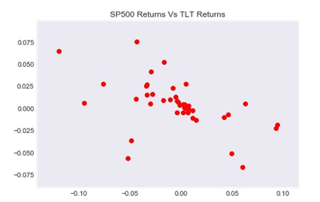

**Interpretation:**

There seems negative correlation between returns of S&P500 and returns of TLT.

# Correlation Matrix

|  |  |  |  |  |
| --- | --- | --- | --- | --- |
| Correlation | S&P500 | Crude oil | Gold | TLT |
| S&P500 | 1.000000 | -0.100655 | 0.091451 | -0.502007 |
| Crude oil | -0.100655 | 1.000000 | 0.159662 | 0.201441 |
| Gold | 0.091451 | 0.159662 | 1.000000 | 0.072155 |
| TLT | -0.502007 | 0.201441 | 0.072155 | 1.000000 |

# Drawdown

## Drawdown of S&P500 due to Covid-19

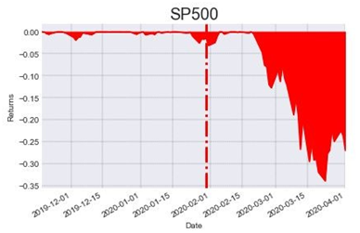

**Interpretation:**

There is about **33% drop in returns of S&P500** from peak.

## Drawdown of Crude Oil due to Covid-19

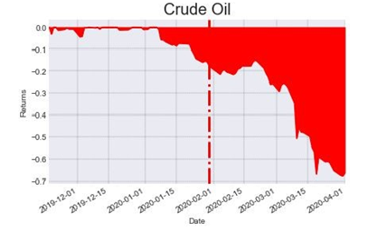

**Interpretation:**

There is **about 67% drop in returns in Crude oil** from peak and which is **maximum** among four instruments.

## Drawdown of Gold due to Covid-19

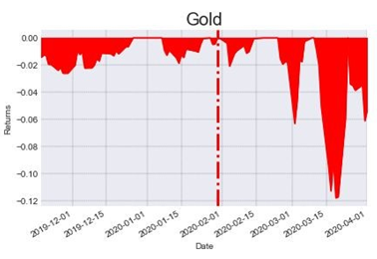

**Interpretation:**

Only **about 12 %** drop **in returns in Gold** from peak which is **minimum** drop among four instruments.

## Drawdown of TLT due to Covid-19

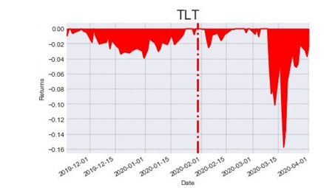

**Interpretation:**

Only **about 16% drop in returns of TLT** from its peak.

### Summary of Drawdown due to Covid-19

|  |  |  |  |
| --- | --- | --- | --- |
| Name of Instrument | Drawdown | Impact of Covid-19 | Relationship with Covid-19 |
| Crude Oil | 67% | Very Highly impacted | Negative correlation |
| S&P500 | 33% | Highly impacted | Negative correlation |
| TLT | 16% | Less impacted | Very Less correlated |
| Gold | 12% | Very less impacted | Very Less correlated |

# IMPACT OF COVID-19 on various sectors.

We collected different sectors data from their respective representative companies (**iShares US**)from Yahoo finance

|  |  |
| --- | --- |
| **Sector** | **Representative Company Name** |
| Pharma | IHE |
| Technology | IYW |
| Financials | IYF |
| Consumer Goods | IYK |
| Telecom | IYZ |
| Basic Materials | ITM |
| Energy | IYE |

## Sectoral performance during Covid-19 outbreak

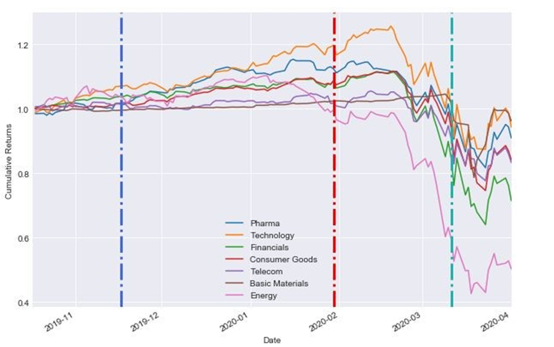

**Interpretation**

Blue vertical dotted line= Date (**Nov 17, 2019)**on which First Covid-19 patient found

Red Vertical dotted line=Date **(Jan 30, 2020)**on which WHO declared "Public Health Emergency"

Green Vertical dotted line=Date **(March 11, 2020)** on which WHO declared Pandemic.

1. **Energy, Financials, and Telecom are the most impacted** and continuously dropping showing downward trend.

2. **Technology, Pharma and Basic Materials** are less impacted.

# Country-by-country Covid-19 trajectory on Apr 05, 2020

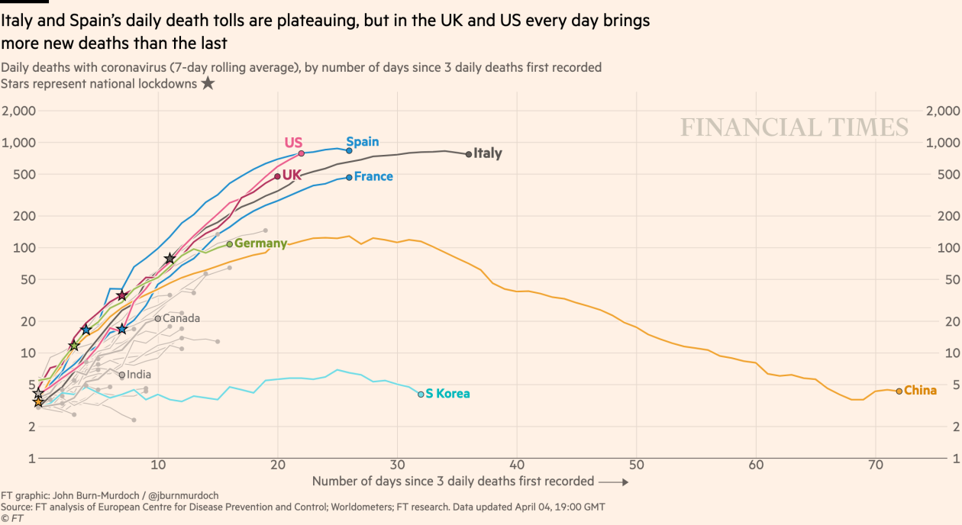

# When Covid-19 will end?

Comparison Between ***Covid-19 and SARS*** (Severe Acute Respiratory syndrome)

There is much similarity between these two viruses except Covid-19 is harder to detect compared to SARS. Both needs social distancing, isolation and quarantine. No drug is effective against both. So for analysis purpose, we can find pattern of SARS in past and can predict how much time it will take Covid-19 to end.

|  |  |  |
| --- | --- | --- |
| **Date** | **Days** | **Key Event** |
| 16-Nov-2002 | 0 | The ﬁrst case of atypical pneumonia is reported in the Guangdong province in southern China. |
| 26-Mar-2003 | 130 | Possible Health Emergency |
| 5-Jul-2003 | 231 | WHO declares that SARS outbreaks have been contained worldwide. |

# SARS Drawdown

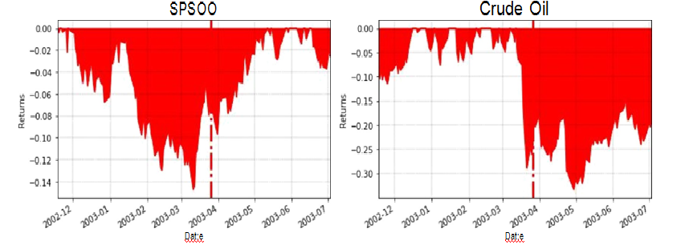

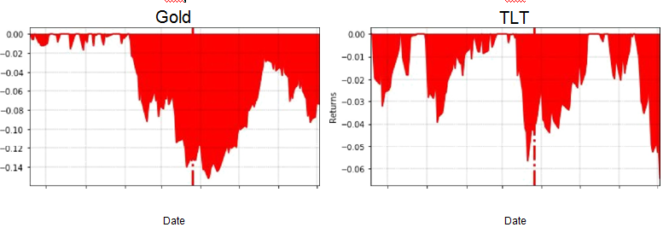

## Table of SARS Drawdown

|  |  |
| --- | --- |
| Name of Financial Instrument | SARS Drawdown |
| Crude Oil | 34% |
| S&P500 | 15% |
| TLT | 5.8% |
| Gold | 15% |

# Impact of SARS on cumulative returns during and after the outbreak

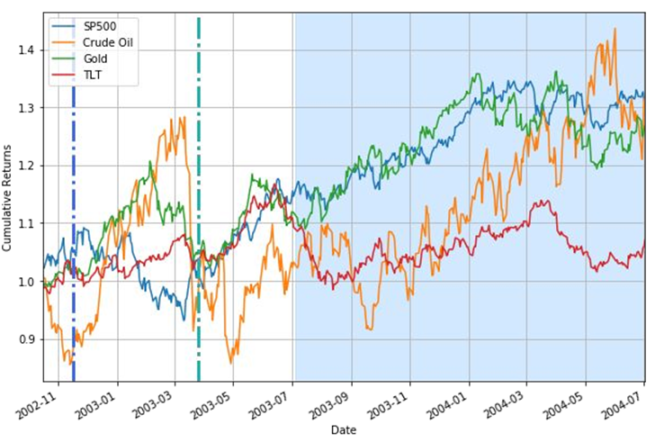

**Interpretation:**

Dark blue region is after outbreak duration when WHO declared SARS is controlled i.e 5 Jul 2003

All financial instruments were going in **upward trend** after outbreak.

It took nearly 100 days to control SARS through social distancing.

Due to same nature of Covid-19 and SARS, it can be predicted that Covid-19 will also take at least 100 days to control it through social distancing.

# Importance of Social Distancing

Following graph shows how cities have flattened curve of cases due to social distancing.

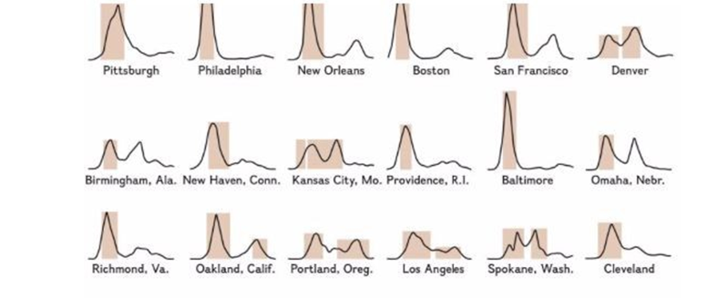

Dark colored area shows social distancing duration.

We can see due to social distancing, cases are falling in all cities during pandemic in 1918.

# Conclusion

* Invest in treasury bond (TLT) as it has negative correlation with S&P500 to protect portfolio and also it is indeed risk-free.
* Gold is safe investment.
* Avoid crude oil as IMF has forecasted recession in 2020 and demand for oil will reduce and thus price of crude oil could continue to fall.
* Energy, Financials, and Telecom are the most impacted during outbreak of COVID-19.
* Technology, Pharma and Basic Materials are less affected.
* Nature of Covid-19 and SARS is pretty much similar.
* Social Distancing the best alternative in any pandemic.

# References

World Health Organization (WHO)- <https://www.who.int/>

Yahoo Finance- <https://finance.yahoo.com/>

Financial Times- <https://www.ft.com/coronavirus-latest>